Quantification of Soluble Protein in Ground Coral Samples

This method for extracting protein from samples is based on the Bradford assay for the colorimetric detection and quantification of total protein (Bradford 1976) and is compared to a known standard dilution of bovine serum albumin (BSA). Pierce Inc. and Bio-Rad have developed the reagents and standards necessary for completing the extraction.
This method was originally developed by Rowan McLachlan in 2018 with the guidance of Dr. Noah Weisleder.

Lab Safety
This procedure uses hazardous chemicals:
- Complete EHS Cryogenic Materials Training before working with liquid nitrogen. Also refer to the Important Notes about Working with Cryogenic Materials (included within this protocol).
- Read the manufacturer’s instructions for the Bio-Rad protein assay (included within this protocol).
- Read the MSDS forms for each chemical in the procedure (included within this protocol).
- Use powder free nitrile exam gloves throughout the procedure (including labelling of vials, excluding use of liquid nitrogen).
- Wear a lab coat and safety glasses throughout the procedure.
- Dispose of all chemical waste in appropriately labeled containers.

Preliminary Sample Preparation (to be done on any day prior to Bradford assay)
The first step for releasing desired biomolecules from within a cell is cell disruption, and the effectiveness of a method determines the accessibility of intracellular proteins for extraction and solubilization. I recommend for efficiency that the following preliminary steps be done on a different day than the Bradford Microassay. Three methods of cell disruption are used in this procedure: grinding, detergent lysis and freeze-thaw lysis.

- Ensure all coral fragments have been sufficiently photographed for surface area measurement prior to grinding.
- Grind frozen coral fragments into a slurry using a chilled mortar and pestle, or within an ice-bath. Attempt to grind the slurry into as fine a consistency as possible (i.e. destroy all skeletal pieces to the best of your ability).
- Using an electronic weighing balance, measure between 0.3-0.5 g of wet ground coral slurry into a 15 ml screw-capped centrifuge tube. Return tube to the freezer as soon as possible.
- When all samples have been partitioned, prepare a 1X solution of RIPA lysis buffer. Pour 15ml of concentrated 10X buffer into a clean Erlenmeyer flask or Nalgene bottle. Using a 10 ml pipette, add 10ml of Milli-Q water to the empty buffer bottle, cap, gentle swirl and then transfer to the Erlenmeyer flask. Repeat three times. Add a further 105 ml of Milli-Q to the Erlenmeyer flask. i.e. 15ml 10X buffer + 135 ml of Milli-Q water => 1X solution of diluted RIPA lysis buffer. Gently swirl diluted buffer to ensure thorough mixing. NOTE: If RIPA buffer will be continually used, it is recommended that the 10X buffer be kept at 4 °C for 1-2 weeks. For longer periods of time, buffer should be stored at -20 °C. Aliquotting of 10X buffer is recommended if many small experiments are being performed.
- Using a 1-1000 μl pipette, add 1 ml of diluted RIPA lysis buffer to each sample centrifuge tube. Use a clean metal spatula to ensure that all slurry in submerged in the buffer at the base of the tube. Vortex each sample of 30 seconds.
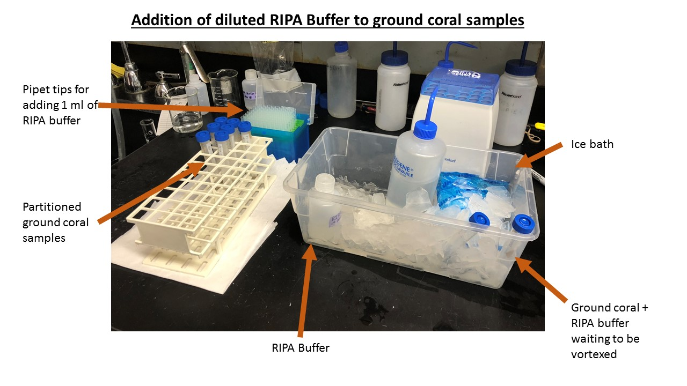
- Partially submerge each centrifuge tube in a bath of liquid nitrogen (maximum depth two inches) for ~10 seconds. Wear eye protection at all times. Only people who have completed the EHS Cryogenic Materials Training should work with liquid nitrogen. Please refer to the Important Notes about Working with Cryogenic Materials at the end of this protocol. NOTE: Ensure that you do not submerge the entire 15 ml centrifuge tube in the liquid nitrogen. RISK OF EXPLOSION.
- Transfer each tube to a room temperature water bath for ~ 2 minutes, or until sample has defrosted completely. Vortex each tube.
- Repeat steps 7 and 8 three times.
- Next, separate the particulate and dissolved material from each sample. Turn on centrifuge and set temperature to 4 °C. It will take ~ 10 mins for the condenser to reach the correct temperature.
- Remove 24 samples (in 15 ml centrifuge tubes) from the freezer, and place in room temperature water bath for ~2 min. Dry each tube, and then load into the swing-bucket centrifuge in balanced configuration. Centrifuge 24 samples for 20 mins at 4200 rpm / 4122 x g, at 4 °C. At the end of the spin, carefully remove the test tubes, so as not to re-suspend particulate slurry. Place samples in ice bucket.
- Using disposable transfer pipettes, remove the supernatant from each 15 ml centrifuge tube, and transfer to a pre-labelled 2 ml Eppendorf tube. Be careful to only collect the middle phase of the supernatant, to avoid sampling the upper phase (whitish matrix) or disturbing the lower phase skeleton. Return the 2 ml Eppendorfs to the freezer until the day of the assay. Do not discard the skeleton and white matrix remaining in the 15 ml centrifuge tube, as these will be needed later for biomass analysis.
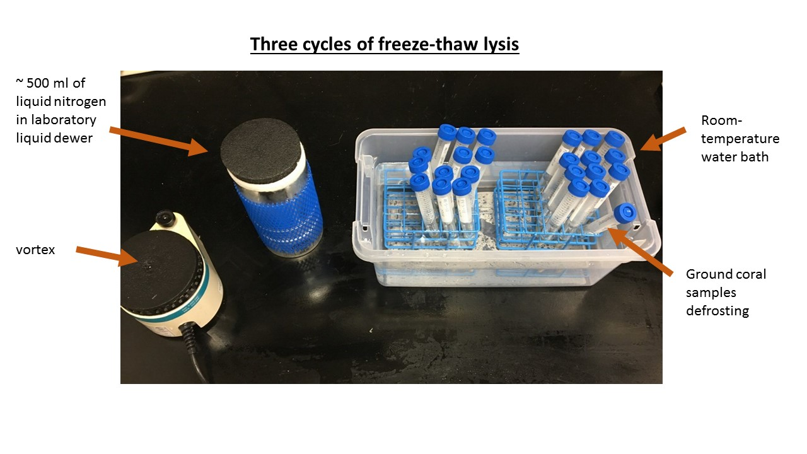

Preparation of BSA Protein Standards (to be done on same day as Bradford assay)

Bovine serum albumin (BSA) standards are available for purchase from several suppliers. For this procedure, 10 x 1 ml albumin standard ampules (2 mg/ml) were purchased from Thermo Scientific. Standards should be prepared on the same day that the Bradford Assay will be conducted.

- Using a sharpie pen, pre-label eight conical Eppendorf tubes (5 ml volume) on the lid and sides with letters A-H.
- Prepare a series of diluted BSA standards ranging from 0 to 500 μg/ml. NOTE: Accurate pipetting technique is very important to perform good measurements. If you have poor pipetting technique, you will not get good data.) Use new pipette tips every time.
- Dilute a 1-ml ampule of BSA (=stock) from as indicated by Table 1. Use Milli-Q water as the diluent. (NOTE: Always discard first 30 seconds of Milli-Q water to purge the system, and also rinse beakers or squirt bottle at least twice with Milli-Q water before filling to reduce contamination. Also, watch display of Milli-Q system, and check the resistance is 18.2 MOhms.cm. If you find a lower value, stop the experiment, and ask the lab manager to service the system.) (Note: Make sure to mix the Stock solution and Milli-Q water well and gently, but do not shake, shaking makes bubbles and is very difficult for accurate pipetting. Just tilt, swirl, and tap gently to mix.
Table 1. Preparation of diluted albumin (BSA) standards for protein analyses.
Dilution  ID# | Volume of Dilutent (Milli-Q) | Volume and Source  of BSA | Final BSA Conc.
A | 1500 μl | 500 μl of stock | 500 μg/ml
B | 800 μl | 200 μl of stock | 400 μg/ml
C | 1700 μl | 300 μl of stock | 300 μg/ml
D | 1500 μl | 1000 μl of dilution A | 200 μg/ml
E | 1000 μl | 1000 μl of dilution D | 100 μg/ml
F | 1000 μl | 1000 μl of dilution E | 50 μg/ml
G | 1000 μl | 0 μl | 0 μg/ml
H | 1000 μl | 0 μl | 0 μg/ml

NOTE: Depending on how many samples and 96-well plates are loaded in a given day, standards may be re-used for subsequent protein assays. However, the challenge of diluted BSA standards is that they need to be protected from microbial growth, evaporation and protein precipitation. These will result in artificially high or low protein concentration values. Including additional sodium azide with the diluted protein standards to maintain a final concentration of 0.05% will help prevent microbial growth. The shelf life of diluted standards can be extended if they are sealed and kept refrigerated.

Bradford Microassay Procedure
These steps were conducted in the lab of Dr. Noah Weisleder (noah.weisleder@osumc.edu, ☎ 614-292-5321). His laboratory is in room 611A, Davis Heart and Lung Research Institute, 473 W. 12th Ave, Columbus, OH, 43210-1252.

* THE 1:5 DILUTION WAS DEEMED APPROPRIATE FOR A 0.5g SAMPLE OF GROUND HAWAIIAN CORAL. THIS MAY VARY DEPENDING ON YOUR SAMPLES. RUNS TESTS AND MAKE SURE SAMPLE VALUES FALL WITHIN THE CENTER OF THE LINEAR RANGE OF YOUR BSA STANDARDS.

- Prepare 250 ml of Bio-Rad protein assay dye reagent from concentrate (keep refrigerated). Using a 10 ml pipet, dilute 1-part dye reagent with 4 parts Milli-Q water into a sterile 50 ml centrifuge tube. Filter dye through a Whatman #1 filter (or equivalent) to remove particulates. NOTE: Diluted reagent may be used for about two weeks when kept at room temperature.
- Using a black sharpie, label the side of polystyrene 96-well microplates with ID number and letters A and B (e.g. 001A, 001A, 002A, 002B etc.). Note for each set of 24 samples, you will need two microplates. Plate A is for dilutions. Plate B is for the Bradford assay.
- All samples are loaded in triplicate within each plate. Remove 2 ml Eppendorf tubes from the freezer and defrost in a water bath for 2 mins. Using a 2 – 10 ul pipet, remove 5 µl of supernatant from each coral sample into appropriate microplate wells in plate A (see 96-well plate loading template). Use clean tips when loading each well. After loading the samples, return all 2 ml Eppendorf tubes to the freezer.
- Using a multichannel pipet (property of Weisleder lab), and a disposable loading tray, add 20 µl of Milli-Q water to the “sample wells” of plate B. This procedure dilutes your coals samples 1:5 (determined as correct range via pilot trial).
- Place plate A on a shake-plate for 1 minute to mix sample and water thoroughly.
- Using a multichannel pipet (property of Weisleder lab), transfer 10 ul from each well of plate B into the wells of plate A.
- Pipet 10 µl of each BSA standard (A-H) into column #1 of tray B. Do not add Milli-Q to these 12 wells.
- Using another multichannel pipet, add 190 µl of 1X diluted dye reagent to every well of the 96-well microplate, starting with column 1. Use clean tips for every well. Record time of dye addition.
- Place plate B on a shake-plate for 1 minute to mix diluted samples/standards and reagent dye thoroughly.
- Incubate plate at room temperature for at least 5 minutes. Absorbance values will increase over time; samples should incubate for no longer than one hour.
- Measure absorbance at 595 nm using a FlexStation® 3 Benchtop Multi-Mode Microplate reader. Manual with full instructions for using the SoftMax Pro software are available online, but briefly: Open SoftMax Pro 5.4.1 > Protocol > Protein Quant > Bradford > Template (create you template here) > Okay > Read > Save As and Copy & Paste into excel.

NOTE: this software automatically calculates the average absorbance of each sample using the triplicate wells, corrects for the two blank standards (cells G1 and H1), plots a standard calibration curve and calculates the protein concentration for each sample.
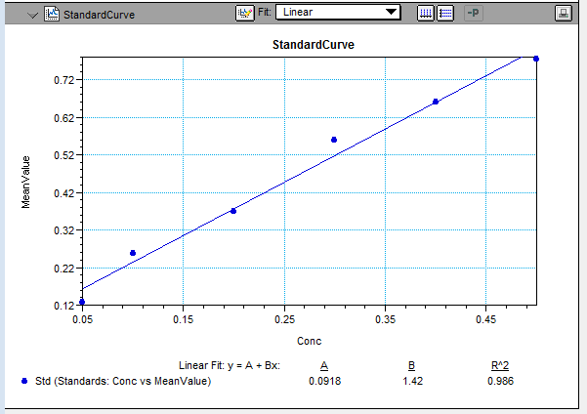

- When all replicate measurements have been made, and you are certain that no duplicates/redos/outliers need to be measured again, the remaining sample may be sacrificed for biomass measurement. Combine the skeleton and white matrix (from step 11) and the remaining soluble protein in RIPA buffer (step 17) into pre-baked aluminum pans. Dry pans under a stream of nitrogen gas on a hot plates set to 100~110ºC for ~15 minutes (Do not increase hot plate temperature too much, as water react with aluminum pan make aluminum oxide and the oxide ruins the weight information)
- Put the nearly dried samples in 60C drying oven overnight.
- Record the dry weight next day.
- Burn the dried sample at 450ºC for 5 hours. Cool them down to room temperature, and record weight. Dry tissue weight is the difference between the weight of the dried sample and the burned sample.

References
Bradford, M.M. 1976. A rapid and sensitive method for the quantification of microgram quantities of protein using the principle of protein-dye binding. Analytical Biochemistry. 72: 248-254.
Noble, J.E. and Bailey, M.J., 2009. Quantitation of protein. In Methods in enzymology (Vol. 463, pp. 73-95). Academic Press.

Dated: May 21st 2018; R. H. McLachlan

Equipment and Chemicals List

Reusable equipment:
- Mortar and Pestles
- Metal spatulas
- Balance
- Erlenmeyer flasks
- Muffle furnace
- 10 ml capacity pipet
- 1000 μl capacity pipette
- 2 μl capacity pipet (property of Weisleder lab)
- 200 μl capacity multichannel pipet (property of Weisleder lab)
- Refrigerated swing bucket centrifuge (4200 rpm / 4122 x g)
- FlexStation® 3 Benchtop Multi-Mode Microplate reader

Disposable equipment required per sample:
- 2 ml & 5 ml Conical Eppendorf™ Tubes (available from Fisher Scientific CAT#: 14-282-302)
- Fisherbrand™ Easy Reader™ Conical Polypropylene Centrifuge Tubes 15 ml sterile (available from Fisher Scientific CAT#: 05-539-5)
- Flat-Bottom Medium Binding 96-Well Microplates, Polystyrene, Clear, Greiner Bio-One (available from VWR, CAT# 82050-716, supplier #:655001)
- VWR® Disposable Pipetting Reservoirs, Divided, Bulk Packed (available from VWR CAT#: 89094-668)
- PIPETMAN® Expert Tipack™ Racked Tips, Gilson®, Sterilized 1-200 µL (available from VWR CAT#: 76178-344)
- Thermo Scientific™ SureOne™ Micropoint Pipette Tips, Specific Standard Fit, Hinged Rack, Non-Filtered, 100 to 1250 µl (available from Fisher Scientific CAT#: 02-707-402)
- 10 ml pipet tips (CAT# to be determined)
- Whatman filter paper (CAT# to be determined)

Chemicals required:
- Pierce™ Bovine Serum Albumin Standard Ampules, 2 mg/mL (available from Fisher Scientific CAT#: PI23209)
- Cell Signaling Technology 15 ml concentrated RIPA Buffer (10X) (available from Fisher Scientific CAT#: 50-195-822)
- Bio-Rad Protein Assay Dye Reagent Concentrate, 450 ml (available from Bio-Rad CAT#: 5000006) One bottle is sufficient for 2250 assays using this procedure.

